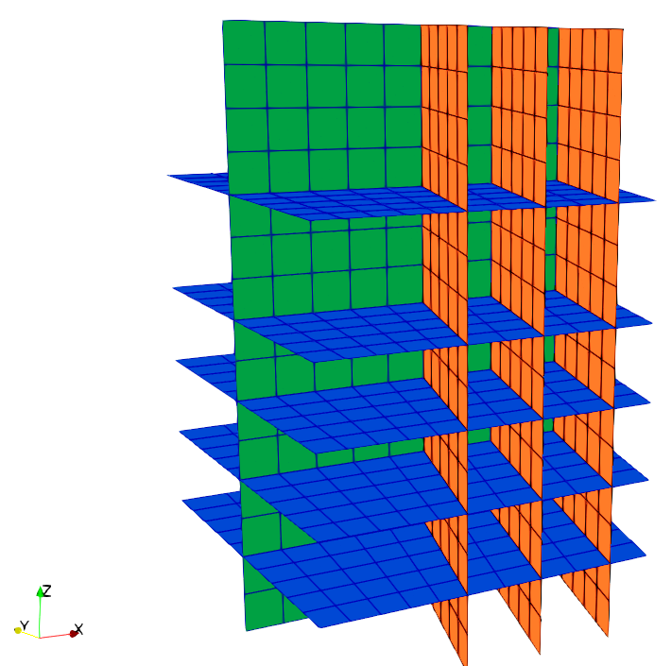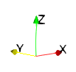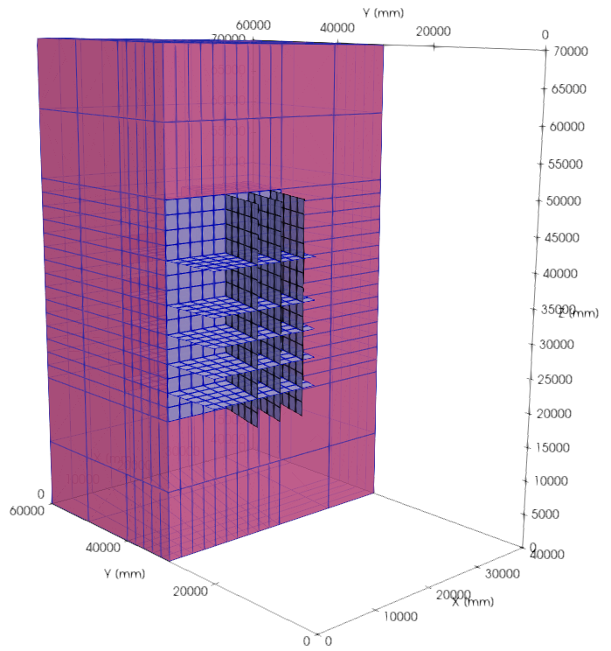

Hydraulic fracture

Weak interface

Discrete fracture networks (DFN)